|  |  |
| --- | --- |
|  | wvrap_logo.jpg  **Logon Requirements**  **Privileges By Wyndham 2014**  **Business and Functional Requirements Specification**  Version 0.9.2  30-th, March 2014  *Author: Andrew Crawford*  \_\_\_\_\_\_\_\_\_\_\_\_\_\_\_\_\_\_\_\_\_\_\_\_\_\_\_\_\_\_\_\_\_\_\_\_\_\_\_\_\_\_\_\_\_\_\_\_\_\_  "LEGAL NOTICE: This document(s) and the information disclosed herein are the proprietary and confidential data of Wyndham Vacations and Resorts Asia Pacific Pty Ltd.  Neither this document(s) nor the information contained within shall be distributed or reproduced without the express written authorization of Wyndham Vacations and Resorts Asia Pacific Pty Ltd." |

## History

|  |  |  |  |
| --- | --- | --- | --- |
| **Version** | **Date** | **Name** | **Brief Description of Each Change** |
| 0.1 | 14/10/2014 | Andrew Crawford | Initial document creation |
| 0.2 | 20/10/2014 | Andrew Crawford | Noted that staff details come from Active Directory (not Venice).  Added New Non-WWID Staff page and modified the Internal Member create screen to allow this.  Removed the new Non-WWID after it was confirmed that the original specification was wrong.  Moved the Change Password reference out since it’s a better fit for the Member Functions. There’s still a reference to this here because it’s also part of the New Member Creation process.  Added the Address fields to the New Non-Owner and Internal Member create pages. |
| 0.3 | 21/10/2014 | Andrew Crawford | Added a check that they entered either a Mobile or Home Phone Number.  Changed the Suburb to Suburb / City  Made the Mandatory fields more visible on the Mock ups. |
| 0.4 | 27/10/2014 | Andrew Crawford | Removed the section Member Types and Formats Section  Removed a redundant reference to generating a temporary username.  Changed the owner Setup / Activation around slightly.  For the member of the public, noted that they are presented with a password after the NAB login.  Changed the user forgotten email steps to make sense.  Put a note under the field formats to explicitly note the back-end system will be doing the main validation.  Dropped the ‘D’ from the discovery member numbers. |
| 0.5 | 28/10/2014 | Andrew Crawford | Numerous changes after review / comments from Nadia. |
| 0.6 | 03/11/2014 | Andrew Crawford | Made sure that Spouse Name is captured for Non-Owners (to bring this in line with Dragon’s data) |
| 0.7 | 10/11/2014 | Andrew Crawford | Changed the Login process so that it’s possible to also do a redirect to the Member Details page (with a custom message) in case we have missing information on Owners or Discovery Members.  Got the redirect process more in line with the messages returned.  Fixed some small formatting issues.  Noted the correct error message to be returned when the user successful initiates a forgot password. |
| 0.8 | 10/02/2015 | Andrew Crawford | Updated this to make sure the Owner / Discovery member login and verification works the same way. |
| 0.9 | 11/02/2015 | Andrew Crawford | Updated the document from Ilona’s comments. |
| 0.9.1 | 16/03/2015 | Andrew Crawford | Added the Password option to the create public page.  Added the Password Recovery Page.  Broke the Reset / Agree Terms pages out of the member page to make it work with.  Changed the word Non-Owner to Public for Members of the Public (to make it less confusing).  Fixed up some formatting of headings.  Removed the JSON Web token part (since we need to revisit this and may not use that).  Made sure that Create new Member has a password field specified if they are a DISCOVERY member.  Updated with comments form Ilona. |
| 0.9.2 | 30/03/2015 | Andrew Crawford | These changes were mainly driven from the Visio workflows where I realised ther was a gap with the member creation.  Added a rule to the Password Recovery page so that this handles if the Toc and Password needs to be updated.  Noted to myself I should call this something else soon because Password Recovery is being used for more than that.  Added the Password and Toc page (so there is a page again where the user can enter both). |

## Related Documents

|  |  |
| --- | --- |
| **Document** | **Location** |
| Privileges Requirement document | T:\Projects\IT Projects\PBW\Privileges 2014\Requirements\ PBW Requirements Spec 2014 v0.4.docx |
|  |  |

Contents

[1.1 History 2](#_Toc414285264)

[1.1 Related Documents 3](#_Toc414285265)

[2 Login Page 6](#_Toc414285266)

[2.1 Navigation to Page 6](#_Toc414285267)

[2.2 Navigation from Page 6](#_Toc414285268)

[2.3 Screen Wireframes 7](#_Toc414285269)

[2.3.1 Screen Fields 7](#_Toc414285270)

[2.4 Screen Actions 7](#_Toc414285271)

[3 Login with JSON Web Token 8](#_Toc414285272)

[4 Forgotten Password Page 8](#_Toc414285273)

[4.1 Navigation to Page 8](#_Toc414285274)

[4.2 Navigation from Page 8](#_Toc414285275)

[4.3 Screen Wireframes 9](#_Toc414285276)

[4.3.1 Screen Fields 9](#_Toc414285277)

[4.4 Screen Actions 9](#_Toc414285278)

[4.5 Password Reset Steps 10](#_Toc414285279)

[5 Forgotten Username Page 10](#_Toc414285280)

[5.1 Navigation to Page 10](#_Toc414285281)

[5.2 Navigation from Page 10](#_Toc414285282)

[5.3 Screen Wireframes 11](#_Toc414285283)

[5.3.1 Screen Fields 11](#_Toc414285284)

[5.4 Screen Actions 11](#_Toc414285285)

[5.5 Username email steps 12](#_Toc414285286)

[6 New User Page 12](#_Toc414285287)

[6.1 Navigation to Page 12](#_Toc414285288)

[6.2 Navigation from Page 12](#_Toc414285289)

[6.3 Screen Design 12](#_Toc414285290)

[6.4 Screen Actions – Worldmark Owner 12](#_Toc414285291)

[7 New WorldMark Member Page 13](#_Toc414285292)

[7.1 Introduction 13](#_Toc414285293)

[7.2 Navigation to Page 13](#_Toc414285294)

[7.3 Navigation from Page 13](#_Toc414285295)

[7.4 Screen Wireframes 13](#_Toc414285296)

[7.4.1 Screen Fields 13](#_Toc414285297)

[7.5 Screen Actions 14](#_Toc414285298)

[8 New Public Member Page 15](#_Toc414285299)

[8.1 Navigation to Page 15](#_Toc414285300)

[8.2 Navigation from Page 15](#_Toc414285301)

[8.3 Screen Wireframes 15](#_Toc414285302)

[8.3.1 Screen Fields 15](#_Toc414285303)

[8.4 Screen Actions 16](#_Toc414285304)

[9 New Employee Member Page 17](#_Toc414285305)

[9.1 Navigation to Page 17](#_Toc414285306)

[9.2 Navigation from Page 17](#_Toc414285307)

[9.3 Screen Wireframes 18](#_Toc414285308)

[9.3.1 Screen Fields 18](#_Toc414285309)

[9.4 Screen Actions 19](#_Toc414285310)

[10 Password Recovery Page 20](#_Toc414285311)

[10.1 Introduction 20](#_Toc414285312)

[10.2 Navigation to Page 20](#_Toc414285313)

[10.3 Navigation from Page 20](#_Toc414285314)

[10.4 Screen Wireframes 20](#_Toc414285315)

[10.5 Screen Actions 20](#_Toc414285316)

[10.6 System Notes 21](#_Toc414285317)

[11 Reset Password 21](#_Toc414285318)

[11.1 Introduction 21](#_Toc414285319)

[11.2 Screen Access 21](#_Toc414285320)

[11.3 Navigation to Page 21](#_Toc414285321)

[11.4 Navigation from Page 21](#_Toc414285322)

[11.5 Screen Wireframes 22](#_Toc414285323)

[11.5.1 Screen Fields 22](#_Toc414285324)

[11.6 Screen Actions 22](#_Toc414285325)

[12 Agree Terms and Conditions Page 22](#_Toc414285326)

[12.1 Introduction 22](#_Toc414285327)

[12.2 Screen Access 22](#_Toc414285328)

[12.3 Navigation to Page 23](#_Toc414285329)

[12.4 Navigation from Page 23](#_Toc414285330)

[12.5 Screen Wireframes 23](#_Toc414285331)

[12.5.1 Screen Fields 23](#_Toc414285332)

[12.6 Screen Actions 23](#_Toc414285333)

[13 Internal Create Member page 23](#_Toc414285334)

[14 Change Password Page 23](#_Toc414285335)

[15 Internal New Member Process 24](#_Toc414285336)

[15.1 System Notes 24](#_Toc414285337)

[15.2 Public Member 24](#_Toc414285338)

[15.3 Discovery Member 24](#_Toc414285339)

[15.4 Privileges White to Owner Transition 24](#_Toc414285340)

[16 System Messages 25](#_Toc414285341)

[17 Membership Types and Formats 26](#_Toc414285342)

[18 Membership Authentication 27](#_Toc414285343)

[18.1 Owners 27](#_Toc414285344)

[18.2 Members of the Public 27](#_Toc414285345)

[18.3 Staff 27](#_Toc414285346)

[19 Non-WWID Staff Members 27](#_Toc414285347)

# Login Page

## Navigation to Page

* Shown when the user navigates to the base Privileges page.
* User clicks on the Login button in the general navigation area
* User clicks on the Logout button in the general navigation area and logout is successful.

## Navigation from Page

* Clicking on the ‘Not a member? Join now’ link takes the user to the New User page.
* Clicking on the ‘Forgot your password’ link takes the user to the Forgotten Password page.
* Clicking on the ‘Forgot your username’ link takes the user to the Forgotten Username page.
* Successfully logging into the system takes the user to the Member Home page.

## Screen Wireframes

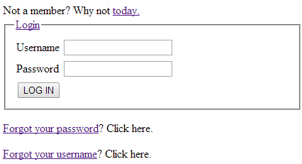

**Note:** This is just a rough guide to required fields and basic layout. It is not intended as a final design

### Screen Fields

|  |  |  |
| --- | --- | --- |
| **Item** | **Type** | **Mandatory** |
| Join now | Link |  |
| Username | Input Field  320 Char | Y |
| Password | Password Field  30 Char | Y |
| LOG IN | Button |  |
| forgotten your password? | Link |  |
| forgotten your username? | Link |  |

## Screen Actions

|  |  |
| --- | --- |
| **Condition** | **Action** |
| * User does not enter a Username. * User clicks on the Login button. | * Message LOGIN\_0001 displayed as an error message. |
| * User does not enter a Password. * User clicks on the Login button. | * Message LOGIN\_0001 displayed as an error message. |
| * User enters a Username and Password. * User Clicks on the Login button. * No user information found. | * Message LOGIN\_0001 displayed as an error message. |
| * User enters a Username and Password. * User clicks on the Login button. * Username does not match any of the required formats (See 4. Membership Types and Formats ) | * Message LOGIN\_0001 displayed as an error message. |
| * User enters a Username and Password. * User clicks on the Login button. * User information found * Password does not match password against user information. | * Message LOGIN\_0001 displayed as an error message. |
| * User enters a Username and Password. * User clicks on the Login button. * User information found * Password matches user credentials. * The Success=LOGIN parameter is returned. | * User is redirected to the Member Home Page. * Message LOGIN\_0002 displayed as an information message. |
| * User enters a Username and Password. * User clicks on the Login button. * User information found * Password matches user credentials. * The Success=REDIRECT parameter is returned. | * User is redirected to the Change Password Page. * Message LOGIN\_0002 displayed as an information message. * Message LOGIN\_0009 is also displayed on the page. |
| * User enters a Username and Password. * User clicks on the Login button. * User information found * Password matches user credentials. * The Success=REDIRECT-TOC parameter is returned. | * User is redirected to the Change Password Page. * The Terms and Conditions checkbox and link are displayed. * Message LOGIN\_0002 displayed as an information message. * Message LOGIN\_0009 is also displayed on the page. * Message LOGIN\_0010 is also displayed on the page. |
| * User enters a Username and Password. * User clicks on the Login button. * User information found * Password matches user credentials. * The Success=REDIRECT-DETAILS parameter is returned | * User is redirected to the Update Member Details page. * Message LOGIN\_0011 is displayed on the page. |
| * User clicks on the ‘Join now’ link | * User is taken to the ‘New User’ page. |
| * User clicks on the ‘Forgot your password’ link | * User is taken to the ‘Forgotten Password’ page. |
| * User clicks on the ‘Forgot your username’ link | * User is taken to the ‘Forgotten Username’ page. |

# Forgotten Password Page

## Navigation to Page

* Shown when the user clicks on ‘Forgotten your password’ on the Login page

## Navigation from Page

* User clicks on the ‘Login’ button in the general navigation area.
* Clicking on the ‘Join now’ link takes the user to the New User page.
* Clicking on the ‘Forgotten your username’ link takes the user to the Forgotten Username page.

## Screen Wireframes

Please enter your Privileges card number and email address so we can send you password reset instructions.

We need to have instruction on this page that notes if they are unsuccessful at entering a username and phone they can also get this done through going to either the contact us form or through phoning us.

This page also needs to note that owners need to have their password reset through the worldmarksp owner site.

Ideally this would be a WCM page that gets loaded into this page with the details.

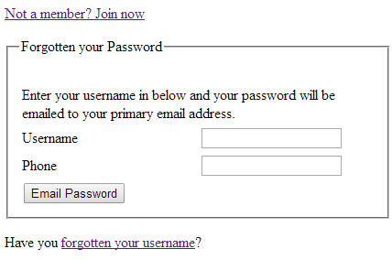

**Note:** This is just a rough guide to required fields and basic layout. It is not intended as a final design

### Screen Fields

|  |  |  |
| --- | --- | --- |
| **Item** | **Type** | **Mandatory** |
| **Join now** | Link |  |
| Username | Input Field  320 Char | Y |
| Phone Number | Input Field  20 Char | Y |
| Email Password | Button |  |
| forgotten your username? | Link |  |

## Screen Actions

|  |  |
| --- | --- |
| **Condition** | **Action** |
| * User does not enter a Username or an Phone Number * User clicks on the Email Password button. | * Message LOGIN\_0005 displayed as an error message. |
| * User enters a Username and Phone Number * User Clicks on the Email Password button. * No user information found. | * Message LOGIN\_0005 displayed as an error message. |
| * User enters a Username and Phone Number * User clicks on the Email Password button. * Username does not match any of the required formats (See 4. Membership Types and Formats ) | * Message LOGIN\_0005 displayed as an error message. |
| * User enters a Username and Phone Number * User clicks on the Email Password button. * User record matches an Owners Details | * Message LOGIN\_0007 displayed as an error error. |
| * User enters a Username and PhoneNumber . * User clicks on the Email Password button. * User information found | * Password resets steps (below) are executed * Message LOGIN\_0006 is displayed as an information message. |

## Password Reset Steps

* Username is verified. If the username is an Owner Number, this is verified against Venice CRM to check if they can access privileges.
* IF the username is an owner number, redirect send back message LOGIN\_0007 (since they need to continue this through the worldmarksp site)
* IF the username is a Tour No Buy, Staff or Discovery Member, then keep on executing the rules below.
* Primary Email is read from the system against the user ID
  + If there is no primary email address associated with the Username, an email is sent to **<Support Mailbox>** noting the users details so the request can be manually processed.
* Set the ‘Change on Login’ flag so the user must enter a new password once they login.
* Sent an email to the primary email address against the username with the temporary password.
* This link will be valid for 72 hours after it has been sent.

# Forgotten Username Page

## Navigation to Page

* Shown when the user clicks on ‘Forgot your Username?’ on the Login or Forgotten Password page.

## Navigation from Page

* User clicks on the ‘Login’ button in the general navigation area.
* Clicking on the ‘Join now’ link takes the user to the New User page.

## Screen Wireframes

We need to have instruction on this page that notes if they are unsuccessful at entering a phone or email details they can also get this done through going to either the contact us form or through phoning us.

Ideally this would be a WCM page that gets loaded into this page with the details.

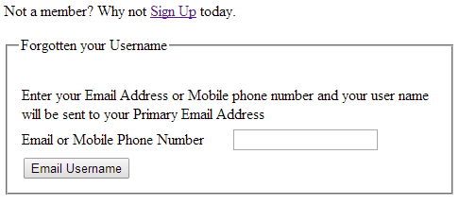

**Note:** This is just a rough guide to required fields and basic layout. It is not intended as a final design

### Screen Fields

|  |  |  |
| --- | --- | --- |
| **Item** | **Type** | **Mandatory** |
| Join now | Link |  |
| Email or Phone Number | Input Field  320 Char | Y |
| Email Username | Button |  |

## Screen Actions

|  |  |
| --- | --- |
| **Condition** | **Action** |
| * User does not enter a value in the Email or Mobile Phone Number field. * User clicks on the Email Username button. | * Message LOGIN\_0005 displayed as an error message. |
| * User does not enter a value in the Email or Mobile Phone Number field. * User clicks on the Email Username button. * No user information found. | * Message LOGIN\_0005 displayed as an error message. |
| * User does not enter a value in the Email or Mobile Phone Number field. * User clicks on the Email Username button. * Username does not match any of the required formats (See 4. Membership Types and Formats ) | * Message LOGIN\_0005 displayed as an error message. |
| * User a value in the User clicks on the Email Username field. * User clicks on the Email Username button. * User information found. | * Username email steps (below) are executed. * Message LOGIN\_0006 is displayed as an information message. |

## Username email steps

* Details are verified.
* If the details match any existing owner, discovery or public email, then the system generates an email with their username and sends it to the Primary email against the account.
* If there is no primary email for the user an email is sent to <**Support Mailbox>** noting the users details so they can be manually contacted.
* If they user has forgotten their password as well, they will need to reset it using the Forgot Password function.

# New User Page

## Navigation to Page

* Shown when the user clicks on ‘Join Now’ on any of the pages

## Navigation from Page

* User clicks on the ‘Login’ button in the general navigation area.
* User is not a Worldmark Owner and they Click ‘No’

## Screen Design

At this point, we need to essentially ask what type of user the Person is. User types are:

* WorldMark Owner
* Discovery Member
* Wyndham Employee
* Member of the Public

We need a way to ask them what sort of user they are (though a button, drop-down, etc) and then show them a unique page or content based off what they have selected.

In case they chose the wrong option, we also need to allow them to go back to this previous page without them having to use the primary ‘New User’ navigation options.

## Screen Actions – Worldmark Owner

|  |  |
| --- | --- |
| **Condition** | **Action** |
| * User indicates that they have a Worldmark Membership | * The ‘New WorldMark Member‘ page appears. |
| * User indicates that they have a Discovery Membership | * They are taken to the ‘New WorldMark Member’ page. |
| * User indicates they are an Wyndham Employee | * They are taken to the ‘New Wyndham Employee Member’ page. |
| * User indicates that they are a Member of the Public. | * They are taken to the ‘New Public Member’ page |

# New WorldMark Member Page

## Introduction

This page is shown where someone identifies as an Owner or Discovery member. At certain owner levels, they have a Privileges Membership automatically created for them. At other levels, they need to pay to receive the Privileges Membership.

This page is intended as a way of checking if they already have a membership, and if they do not, give them an option to purchase membership.

If they already have a membership, there is an error message that redirects them to other pages to try to gain access.

## Navigation to Page

* Shown when the user clicks on ‘Yes’ to the Owner or Discovery Member

## Navigation from Page

* User navigates back to the previous screen to select a different user type.
* User clicks on Create Membership and all validations pass and is taken to the NAB Payment page.

## Screen Wireframes

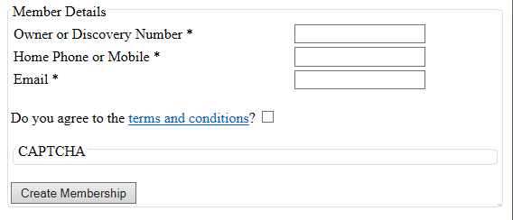

**Note:** This is just a rough guide to required fields and basic layout. It is not intended as a final design

### Screen Fields

|  |  |  |
| --- | --- | --- |
| **Item** | **Type** | **Mandatory** |
| Owner or Discovery Member Number | Input Field  20 CHAR | Y |
| Home Phone or Mobile | Input Field  20 CHAR | Y |
| Email | Input Field  320 CHAR | Y |
| Password | Input Field  **Note:** This only appears for Discovery Members | Y |
| Re Enter Password | Input Field  **Note:** This only appears for Discovery Members | Y |
| Do you agree to the Terms and Conditions | Label (With Hyperlink)  This is label asking if they accept terms and conditions.  The words ‘Terms and Conditions’ are a hyperlink to the Terms and Conditions page. |  |
| Agree to Terms and Conditions | Checkbox | Y |
| CAPTCHA | Typical web-captcha needed to be entered by a user before the form submits. |  |
| Create Membership | Button |  |

## Screen Actions

|  |  |
| --- | --- |
| **Condition** | **Action** |
| * User Clicks on Create Membership * Mandatory field is missing | * The message CREATE\_0001 appears as an error with the value ‘$1’ substituted for the missing value. * One message will appear per missing mandatory field, so this message may appear multiple times. |
| * User Clicks on Create Membership * Agree to Terms and Conditions checkbox is not checked. | * The message CREATE\_0002 appears as an error. |
| * User Clicks on Create Membership * Captcha is incorrect | * The 3rd party Captcha plugin will display an appropriate error message. |
| * User Clicks on Create Membership * All mandatory fields are filled in * Captcha has been completed successfully * An existing Owner or Discovery membership is found for the user. * A Privileges membership is not found for the user.   **Note:** This is for when an Ownership was created, but the corresponding Privileges membership has not yet been created. | * The message CREATE\_0008 appears as an error. |
| * User Clicks on Create Membership * All mandatory fields are filled in * Captcha has been completed successfully * The member number, phone and email are checked against existing Member Details * The details found against the owner number do not match the details entered by the user. | The message CREATE\_0005 appears as an error. |
| * The member is a DISCOVERY member. * The value against ‘Password’ and ‘Reenter Password’ do not match. | The message CREATE\_0007 appears as an error. |
| * User Clicks on Create Membership * All mandatory fields are filled in * Captcha has been completed successfully * No existing membership was found | * The user is taken to the external NAB payment gateway page for our account. |
| * NAB Payment successfully processed | * The user is shown a page or fields that allow them to set their initial password. * This should be the same or similar layout used with the ‘Forgotten Password’ page. * Once a new password is entered, the create member webservice can be called. |

# New Public Member Page

## Navigation to Page

* Shown when the user clicks on ‘ ‘Member of the public’

## Navigation from Page

* User clicks on the ‘Join now’ button in the general navigation area and is taken to the login page.
* User clicks on Create Membership and all validations pass and is taken to the NAB Payment page.

## Screen Wireframes

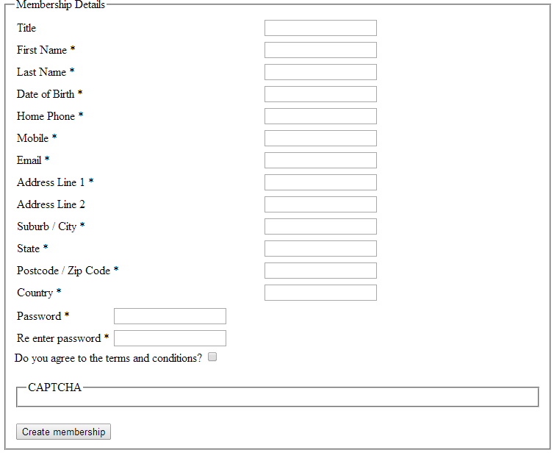

**Note:** This is just a rough guide to required fields and basic layout. It is not intended as a final design

### Screen Fields

|  |  |  |
| --- | --- | --- |
| **Item** | **Type** | **Mandatory** |
| Title | Input Field  20 CHAR | N |
| First Name | Input Field  50 CHAR | Y |
| Partner Name | Input Field  50 CHAR | N |
| Last Name | Input Field  50 CHAR | Y |
| Date of Birth | Date Picker  Date format should be: Day (2 Digits) / Month (2 Digits) / Year (4 Digits) | Y |
| Phone | Input Field  20 CHAR | (Conditional) |
| Mobile | Input Field  20 CHAR | (Conditional) |
| Email | Input Field  320 CHAR | Y |
| Address Line 1 | Input Field  100 CHAR | Y |
| Address Line 2 | Input Field  100 CHAR | N |
| Suburb / City | Input Field  50 CHAR | Y |
| State | Drop down – Australian States  Or  Input Field  50 CHAR | Y |
| Postcode  Or  Postcode / Zip Code | Input Field  10 CHAR | Y |
| Country | Drop-down – Defaulted to Australia.  If they change the country to anything other than Australia, state is changed to an Input Field (100 Char).  Postcode label changed to Postcode / Zip Code when country is anything other than Australia. | Y |
| Do you agree to the Terms and Conditions | Label (With Hyperlink)  This is label asking if they accept terms and conditions.  The words ‘Terms and Conditions’ are a hyperlink to the Terms and Conditions page. |  |
| Agree to Terms and Conditions | Checkbox | Y |
| Password | Input Field | Y |
| Re Enter Password | Input Field | Y |
| CAPTCHA | Typical web-captcha needed to be entered by a user before the form submits. |  |
| Create Membership | Button |  |

## Screen Actions

|  |  |
| --- | --- |
| **Condition** | **Action** |
| * User Clicks on Create Membership * Mandatory field is missing or incorrect | * The message CREATE\_0001 appears as an error with the value ‘$1’ substituted for the missing value. * One message will appear per missing mandatory field, so this message may appear multiple times. |
| * User Clicks on Save Details * Mandatory fields filled in. * Mobile and Home Phone is not filled in. | * The message CREATE\_0001 appears as an error with the value ‘$1’ substituted for the value ‘Mobile or Home Phone’. |
| * User Clicks on Create Membership * Agree to Terms and Conditions checkbox is not checked. | * The message CREATE\_0002 appears as an error. |
| * User Clicks on Create Membership * Captcha is incorrect | * The 3rd party Captcha plugin will display an appropriate error message. |
| * The value against ‘Password’ and ‘Reenter Password’ do not match | * The message CREATE\_0007 appears as an error. |
| * User Clicks on Create Membership * All mandatory fields are filled in * Captcha has been completed successfully * The email address given is checked against existing Privileges memberships. * A match is found against existing privileges memberships. | * The message CREATE\_0003 appears as an error. * The error message contains links to the ‘Forgot Password’ page against the text ‘Forgotten Password’ |
| * User Clicks on Create Membership * All mandatory fields are filled in * Captcha has been completed successfully * No existing membership was found | * The user is taken to the external NAB payment gateway page for our account. |
| * NAB Payment successfully processed | * The user is shown a page or fields that allow them to set their initial password. * This should be the same or similar layout used with the ‘Forgotten Password’ page. * Once a new password is entered, the create member webservice can be called. |

# New Employee Member Page

## Navigation to Page

* Shown when the user clicks on ‘ Wyndham Employee’

## Navigation from Page

* User clicks on the ‘Join now’ button in the general navigation area and is taken to the login page.
* User clicks on Create Membership and all validations pass and is taken to the NAB Payment page.

## Screen Wireframes

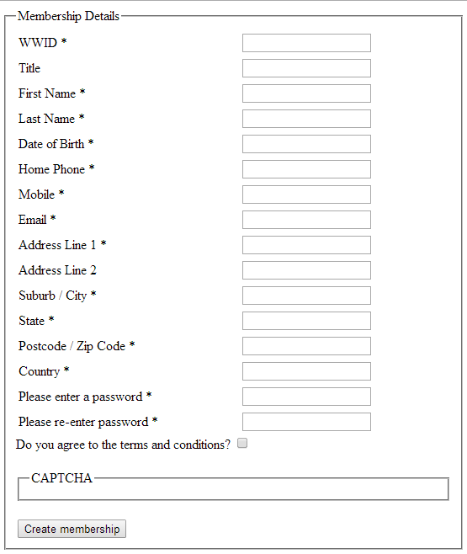

**Note:** This is just a rough guide to required fields and basic layout. It is not intended as a final design

### Screen Fields

|  |  |  |
| --- | --- | --- |
| **Item** | **Type** | **Mandatory** |
| WWID | Input Field  6 CHAR | Y |
| Title | Input Field  20 CHAR | N |
| First Name | Input Field  50 CHAR | Y |
| Last Name | Input Field  50 CHAR | Y |
| Date of Birth | Date Picker  Date format should be: Day (2 Digits) / Month (2 Digits) / Year (4 Digits) | Y |
| Phone | Input Field  20 CHAR | (Conditional) |
| Mobile | Input Field  20 CHAR | (Conditional) |
| Email | Input Field  320 CHAR | Y |
| Address Line 1 | Input Field  100 CHAR | Y |
| Address Line 2 | Input Field  100 CHAR | N |
| Suburb / City | Input Field  50 CHAR | Y |
| State | Drop down – Australian States  Or  Input Field  50 CHAR | Y |
| Postcode  Or  Postcode / Zip Code | Input Field  10 CHAR | Y |
| Country | Drop-down – Defaulted to Australia.  If they change the country to anything other than Australia, state is changed to an Input Field (100 Char).  Postcode label changed to Postcode / Zip Code when country is anything other than Australia. | Y |
| Password | Input Field | Y |
| Re Enter Password | Input Field | Y |
| Do you agree to the Terms and Conditions | Label (With Hyperlink)  This is label asking if they accept terms and conditions.  The words ‘Terms and Conditions’ are a hyperlink to the Terms and Conditions page. |  |
| Agree to Terms and Conditions | Checkbox | Y |
| CAPTCHA | Typical web-captcha needed to be entered by a user before the form submits. |  |
| Create Membership | Button |  |

## Screen Actions

|  |  |
| --- | --- |
| **Condition** | **Action** |
| * User Clicks on Create Membership * Mandatory field is missing or incorrect | * The message CREATE\_0001 appears as an error with the value ‘$1’ substituted for the missing value. * One message will appear per missing mandatory field, so this message may appear multiple times. |
| * User Clicks on Save Details * Mandatory fields filled in. * Mobile and Home Phone is not filled in. | * The message CREATE\_0001 appears as an error with the value ‘$1’ substituted for the value ‘Mobile or Home Phone’. |
| * User Clicks on Create Membership * Agree to Terms and Conditions checkbox is not checked. | * The message CREATE\_0002 appears as an error. |
| * User Clicks on Create Membership * Captcha is incorrect | * The 3rd party Captcha plugin will display an appropriate error message. |
| * The value against ‘Password’ and ‘Reenter Password’ do not match | * The message CREATE\_0007 appears as an error. |
| * User Clicks on Create Membership * All mandatory fields are filled in * Captcha has been completed successfully * The email address given is checked against existing Privileges memberships. * A match is found against existing privileges memberships. | * The message CREATE\_0003 appears as an error. * The error message contains links to the ‘Forgot Password’ page against the text ‘Forgotten Password’ |
| * User Clicks on Create Membership * All mandatory fields are filled in * Captcha has been completed successfully * No existing membership was found | * The user is taken to the external NAB payment gateway page for our account. |
| * NAB Payment successfully processed | * The user is shown a page or fields that allow them to set their initial password. * This should be the same or similar layout used with the ‘Forgotten Password’ page. * Once a new password is entered, the create member webservice can be called. |

# Password Recovery Page

## Introduction

When a user uses the forget password action, this page is used as a landing page for an email link for all user types – except Owners. The page will be passed a token which it will call a service to check if it’s valid or not and either log the user in or redirect depending on their membership type.

## Navigation to Page

* User clicks on a link from an email and the page is opened up directly.
* User clicks on ‘Submit’ from ‘Forgot Password’ page, and system identifies user type as an Owner

## Navigation from Page

* User navigates with the normal Privileges navigation

## Screen Wireframes

There are no input fields on the screen.

An error message may possibly appear, but it is expected this screen should be redirecting to another screen.

## Screen Actions

|  |  |
| --- | --- |
| **Condition** | **Action** |
| * Page is loaded with the unique token passed as part of the URL. * Page passed the unique token to the Password Recovery Service. * The password recovery service returns ‘EXPIRED’ | * The message LOGIN\_0012 is shown on the screen. |
| * Page is loaded with the unique token passed as part of the URL. * Page passed the unique token to the Password Recovery Service. * The password recovery service returns ‘REDIRECT’ and a SessionID | * The user is navigated to the Reset Password page (to change their password) * This option is only available if they are a member of the public, Tour-No-Buy, Staff and Discovery. |
| * Page is loaded with the unique token passed as part of the URL. * Page passed the unique token to the Password Recovery Service. * The password recovery service returns ‘REDIRECT-URL’, a URL and a SessionID. | * The URL is opened up in a new window. * The user is logged into the system. * This action is intended for Owners since Privileges cannot actually handle their password resets. The URL will be a WCM hosted page detailing how they need to reset their password. |
| * Page is loaded with the unique token passed as part of the URL. * Page passed the unique token to the Password Recovery Service. * The password recovery service returns ‘REDIRECT-PASS-TOC’. | * The user is navigated to the Reset Password and Terms and Conditions page (to change their password and re-accept terms and conditions). * This option is only available if they are a member of the public, Tour-No-Buy, Staff and Discovery. |

## System Notes

Since we (Wyndham)are generating the email internally, we will need to the URL to call with the token. This will be embedded as a link in an email, so it either needs to have the token passed as part of the URL itself or as a named parameter. We are happy to do this either way.

Just let us know the URL to put in the email.

# Reset Password

## Introduction

This was to link into the Forgotten Password service and the response from the Login service (REDIRECT)

We already have a reset password page for members (Member – Change Password – Public and Staff). This was explicitly just for resetting the password.

## Screen Access

This is only shown when the user type is ‘PUBLIC’, ‘STAFF’ or ‘DISCOVERY’. No other user types can reset their password in Privileges.

## Navigation to Page

* This is shown when the Login service returns ‘REDIRECT’. This will show the ‘Password’ and re-enter password’ fields.
* This is shown when the Password Recovery service returns ‘REDIRECT’

## Navigation from Page

* Using the standard Privileges menu options

## Screen Wireframes

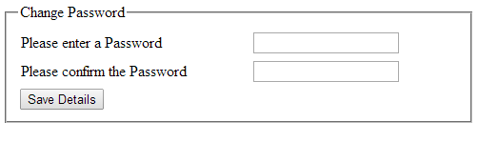

**Note:** This is just a rough guide to required fields and basic layout. It is not intended as a final design

### Screen Fields

|  |  |  |
| --- | --- | --- |
| **Item** | **Type** | **Mandatory** |
| Password | Input field | Y |
| Re-enter Password | Input Field | Y |

## Screen Actions

|  |  |
| --- | --- |
| **Condition** | **Action** |
| * A mandatory field is missing from the screen. | * The message PASSWORD\_0001 appears as an error message. |
| * The value against ‘Password’ and ‘Reenter Password’ do not match | * The message CREATE\_0007 appears as an error message. |
| * User sees either Password field. * User successfully enters a password. * Any earlier validations with the old password and the re-entered password pass (if the fields are shown). * The Update Password Service returns a success response. | * The message PASSWORD\_0003 appears as an information message. |

# Agree Terms and Conditions Page

## Introduction

This will only be shown if the Login service returned ‘REDIRECT-TOC’.

This was specified as a separate page, but it should be similar in content to the Reset password page (from the Member screen)

## Screen Access

All roles will be able to access this page.

## Navigation to Page

* This will only be shown when the login service returns ‘REDIRECT-TOC’

## Navigation from Page

* A user cannot navigate away from this page. They must accept it the terms and conditions to be able to access Privileges

## Screen Wireframes

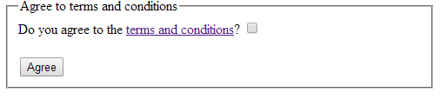

**Note:** This is just a rough guide to required fields and basic layout. It is not intended as a final design

### Screen Fields

|  |  |  |
| --- | --- | --- |
| **Item** | **Type** | **Mandatory** |
| Updated terms and conditions | Label (with Link)  The Terms and Conditions text contains a link that opens up a WCM page in a new window. |  |
| Accept checkbox | checkbox | Y |

## Screen Actions

|  |  |
| --- | --- |
| **Condition** | **Action** |
| * The checkbox **is not** checked * The user clicks on the Agree Button. | * The message LOGIN\_0010 appears as an error message. |
| * The checkbox is checked. * The user clicks on the Agree button. | * The user is taken to the Privileges home page. |

# Agree Password and Terms and Conditions Page

## Introduction

This will only be shown if the Login service returned ‘REDIRECT-PASS-TOC’.

This was specified as a separate page, but it should be similar in content to the Reset password page (from the Member screen)

## Screen Access

All roles will be able to access this page.

## Navigation to Page

* This will only be shown when the login service returns ‘REDIRECT-PASS-TOC’

## Navigation from Page

* A user cannot navigate away from this page. They must enter a password and accept Terms and conditions to continue.

## Screen Wireframes

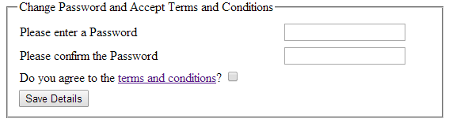

**Note:** This is just a rough guide to required fields and basic layout. It is not intended as a final design

### Screen Fields

|  |  |  |
| --- | --- | --- |
| **Item** | **Type** | **Mandatory** |
| Password | Input field | Y |
| Re-enter Password | Input Field | Y |
| Terms and Conditions | Label (with Link)  The Terms and Conditions text contains a link that opens up a WCM page in a new window. |  |
| Accept checkbox | checkbox | Y |

## Screen Actions

|  |  |
| --- | --- |
| **Condition** | **Action** |
| * A mandatory field is missing from the screen. | * The message PASSWORD\_0001 appears as an error message. |
| * The checkbox **is not** checked   The user clicks on the Agree Button. | * The message LOGIN\_0010 appears as an error message. |
| * The value against ‘Password’ and ‘Reenter Password’ do not match | * The message CREATE\_0007 appears as an error message. |
| * User sees either Password field. * User successfully enters a password. * Terms and Conditions have been agreeded. * Any earlier validations with the old password and the re-entered password pass (if the fields are shown). * The Update Password Service returns a success response. | * The message PASSWORD\_0003 appears as an information message. * The user is shown the Privileges Home screen. |

# Internal Create Member page

There is no explicit internal member create page.There needs to be a screen to allow a bulk / manual upload form for adding people to Privileges that bypasses the payment checks and validation to check against existing memberships.

# Change Password Page

**Note:** This is detailed in the Member Login page, but it also accessible by the Internal New Member process.

# Internal New Member Process

## System Notes

This process is run for any new Privileges membership created.

There is no screen for this, so this section is purely to define the business rules of what happens once a member is created through the external new member pages or the internal new member page.

A membership is not considered active for a Discovery or Public Member unless they have activated this via the Password Link and successfully changed their password.

All new memberships are sent the appropriate email through their standard processing.

## Public Member

* The system sends an Welcome email containing a link to the ‘change/ Set-up Password’
* If the user was created internally, the Change Password page also contains the Terms and Conditions (with accompanying checkbox) that the user has to agree to.
* If the account is not activated in 72 hours, the link expires.
* A link can be re-sent through the ‘Reset Password’ page on the Internal System.

## Discovery Member

* The system sends an Welcome email containing a link to the ‘Change/ set-up Password’
* If the user was created internally, the Change Password page also contains the Terms and Conditions (with accompanying checkbox) that the user has to agree to.
* If the account is not activated in 72 hours, the link expires.
* A link can be re-sent through the ‘Reset Password’ page on the Internal System.

## Privileges White to Owner Transition

* The LeadID should be common to both a Privileges White Member and a New Owner
* This should be able to be matched when an ownership is being created in Privileges to check if the details need to be updated against an existing membership or a completely new membership needs to be created.

# System Messages

This is intended as a list of unique error or information messages generated by the system.

|  |  |  |
| --- | --- | --- |
| **Message No.** | **Title** | **Text** |
| LOGIN\_0001 | Sorry, your login was unsuccessful | Your username or password is invalid, please try again. |
| LOGIN\_0002 | Login Successful | You are now logged in to Privileges. |
| LOGIN\_0003 | Logout Successful | You have been logged out of Privileges. |
| LOGIN\_0004 | Logout | Are you sure you want to Logout?  Any items in your cart will be removed. |
| LOGIN\_0005 | User details not found | Your user details were not found.  If you are not a Privileges member, you can Sign Up today. |
| LOGIN\_0006 | Email Sent | Information on resetting your password has been sent to your listed primary email address.. |
| LOGIN\_0007 |  |  |
| LOGIN\_0008 | Email Sent | Your username has been sent to your listed primary email address. |
| LOGIN\_0009 | Change Password | Please change your password |
| LOGIN\_0010 | Terms and Conditions | You must read and accept the Terms and Conditions to access Privileges. |
| LOGIN\_0011 | Information Missing | We are missing some information against your membership. Please fill in the required fields. |
| LOGIN\_0012 | Password Recovery Failed | Your password recovery failed.  Please try this again. |
| CREATE\_0001 | Mandatory field missing | The field $1 needs to be filled in with correct values for you to create a Privileges membership. |
| CREATE\_0002 | Terms and Conditions not Agreed | You must read and agree to the Terms and Conditions to create a Privileges account. |
| CREATE\_0003 | An account exists with this email | A Privileges account is already set up with this email address. If you need to reset your password, please go to the Forgotten Password page. |
| CREATE\_0004 | An account exists with this email | A Privileges account is already set up against this email address. You can re-send the password through the ‘Forgotten Password’ page. |
| CREATE\_0005 | No Ownership or Membership Found | No Ownership or Membership could be found with the details given. Please call **XXX XXX** to talk to a consultant if you need assistance creating your account. |
| CREATE\_0006 | **Note:** This message code is no longer used, but kept in here because there were codes generated after.  This can be used if we ever need a new message. |  |
| CREATE\_0007 | Passwords do not Match | Your entered and confirmed passwords do not match. |
| CREATE\_0008 | Membership being Created | Your membership is being processed. |
| CREATE\_0009 | Membership Details Exist | You already have access to Privileges. If you have forgotten your login details, you can resend your username or reset your password. |
| PASSWORD\_0001 | Mandatory field missing | The field $1 needs to be filled in with correct values for you to change your password |
| PASSWORD\_0002 | Password does not match | The password you entered does not match the current password we have recorded. |
| PASSWORD\_0003 | Your password has been changed | Your password has been changed in Privileges |

# Membership Types and Formats

|  |  |  |  |
| --- | --- | --- | --- |
| **Membership Type** | **Description** | **Format** | **Example** |
| White Membership | Tour No Buy | Privileges Number  The text ‘WH’ + Digits | WH123456 |
| Staff | Staff members with a Wyndham Worldwide ID (WWID) | 6 Digits | 123456 |
| Blue | Owner without Privileges | Owner Number  2 Leading zeros + 9 Digits  Or 3 leading zeros + 8 digits | 00223456789  Or  00071234567 |
| Privileges  Elite  Diamond  Platinum  100 Club | Owner with Privileges | Owner Number  2 Leading zeros + 9 Digits  Or  3 leading zeros + 8 Digits | 00223456789  Or  00071234567 |
| Discovery | Discovery Member | Discovery Number  2 Leading zeros + 9 Digits  OR  3 Leading Zeros + 8 Digits | 00123456789  Or  00071234567 |

**Note:** The back-end system will do more detailed validations; we are just expecting some very basic type validations from the front-end system.

# Membership Authentication

## Owners

Owners are authenticated against the US Site using the current screen capture methods. The system will not store an owner’s password at any stage and will work out dynamically if they are eligible for Privileges or not through looking at their current ownership level.

## Discovery

Discovery members are authenticated with the common authorisation service. This gives them a single sign-on that they use for accessing common Wyndham systems.

## Members of the Public

Members of the Public will have their username and password stored within the system. The system will authenticate them with the single sign-on system that use for accessing common Wyndham systems.

## Staff

Although we have the ability to authenticate staff with Active Directory, we do not do so for the Privileges system. The main reason for that is that all staff members are not in Active Directory and it is too much of an administrative burden to add and remove staff members to this. Staff lists are taken from the Payroll system and the password that staff members use is local the Privileges system.

**Note:** Owner numbers need to be validated against Venice to get the current owner level and determine if they are eligible for Privileges or not.

# Non-WWID Staff Members

The main Privileges requirements document has a note about Staff members without a WWID being able to self-create an account and access Privileges with a Qantel ID.

Further investigation has shown that all staff members (including Call Centre staff members) are issued a WWID, so this requirement was dropped from the project.